**Snow White Interactive Story**

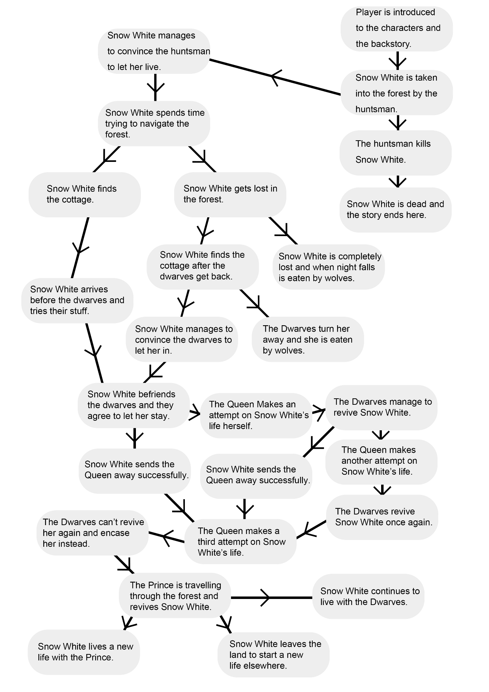

Premise

A girl called Snow White is the fairest girl in the land and the Queen (Snow White’s stepmother) is angered by this and orders Snow White’s execution; she ordered a huntsman to murder Snow White, however the huntsman feels guilty about killing her, so he allows her to live in the forest. After running through the forest Snow White stumbles upon a cottage and decides to take shelter there. The dwarves come back to find Snow White in their home. Snow White and the dwarves arranged that she could stay at the cottage. Finding out the Snow White was still alive the Queen made three more attempts on Snow White’s life. The first two times the dwarves managed to revive Snow White. However, on the final time they could not. The dwarves, not wanting to bury Snow White kept her in a glass case. One day a prince was travelling through the forest and stumbled upon the cottage. The dwarves allowed the prince to have the case and while his men were carrying it they stubbled and the piece of apple dislodged from Snow White’s throat, reviving her. The prince and Snow White then agreed to marry, and the Queen learned that Snow White still yet lived and because of this she ran away from the kingdom never to be seen again.

The player will play as Snow White and will make choices that lead her through the story. The story engine I will be using is Inform 7 because I want to create more of a sense of adventure and more feeling of player agency for the player as well as narrative fabula and discourse which I think can come across better with text adventure games than hypertexts. I will take a few liberties in terms of adding character depth and changing a few of the character traits. The game will have three endings: Snow White can marry the prince, live with the dwarves or move away from the continent altogether. Also, along the way the player will be able to die, ending the story there.

Plot

This game will be a standalone story. It will be about 20 minutes long with many player choices and player agency along the way. The story will be at a relatively balanced pace, giving enough time for certain story landmarks to become digested by the player. The parts of the story where the player isn’t having any impact or agency, I will try to get through quickly such as the start of the story which is mainly character and world building. As the player will be playing as Snow White; I will try to keep the parts of the story where the player has no knowledge of or is not directly impacted by certain events (such as what the Queen is doing most of the time and what she is planning) hidden from them. This may seem like not much is happening through the perspective of the player; half of the story will just not be seen by the player because it is not experienced by Snow White. For scenes like the one where Snow White is dead after eating the apple I will make it so the player cannot do anything or see or hear anything, they will theoretically be dead and will have no player agency at that point. However, because I want to limit the amount of time that the player has no agency I will make the pacing of these events a lot faster. I will try to make the story more interesting by constantly pairing high action encounters like whenever the Queen arrives with much less stressful moments like Snow White just having to do house chores.

Character Design

**Snow White:** Snow White will take the role of the main protagonist in the game; she is who the player will take control of.In terms of Jungian archetypes Snow White could be considered the maiden archetype because of her beauty, purity and desire. She can also be associated with the ‘everywoman’ game archetype because although she does have immense beauty she is also just a normal woman. Snow White’s persona personality framework discussed by Carl Jung would be she is very innocent, naïve and trusting as well as very elegant, beautiful, caring and inherently nice. Her shadow would be largely the same because she is not hiding parts of her personality from people, she does just mean well.

**The Queen:** The queen is the main antagonist of the game and her goals and what drives her will directly contrast Snow White. Her Jungian archetype is the devil because of her dangerous nature and the trickster because of her constant deceiving and hidden identities she presents as well as having hints of the wise old woman because of the essence of her cunning plans to end Snow White’s life discreetly. The Queen’s Jungian persona is similar to Snow White’s; she is innocent, beautiful and powerful. However, her shadow self is extremely manipulative, selfish, evil and sadistic.

**The Dwarves:** The dwarves are NPCs in the game and will attempt to aid Snow White in several different situations. The Jungian archetypes linked with the dwarves are that of wise-old men, they are cautious of Snow White to begin with although when they discover her pure hearted quality they allow her to stay with them, so long as she also aids them. The Dwarves Jungian persona is cautious, hard-working, caring and empathetic. The shadow of the Dwarves personality is, like Snow White’s case largely similar to their persona because they aren’t trying to hide parts of themselves from others.

Structure Justification and Approach to Agency

In my story graph I have got examples of Bernstein’s non-linear patterns and I have used them to create a much more interactive narrative from the original **text**. The main **Bernstein’s patterns** I have used are the **split-join** pattern which creates two trees of choices that then join again further down the story graph, I have used this for when Snow White is trying to navigate the forest and also when the Queen arrives at the cottage the first two times, she tries to kill Snow White. The **split-join** is a fundamental pattern used in interactive native; often giving the player the illusion of choice or **modular** choices that do not affect the overall **fabula** of the story but instead affect it on a **discourse** level, only changing how the player experiences the story and not actually altering the outcome of the story. I have included a few **modular discourse** choices for the player to make throughout the story such as if Snow White is killed by the huntsman or if she gets lost in the forest or is turned away by the Dwarves she can die at that point and the story ends there. For structure I went with the **beads on a string** structure that is commonly used in games and other interactive narratives because it involves multiple **split-joins** put together and although it can affect the narrative at a **fabula** level it quite often only affects it at a **discourse** level and then changes the ending of the narrative with one final decision, this is also what I opted because it allows for a good amount of **player agency** but also doesn’t demand multiple branching narratives. As mentioned before I wanted to create a narrative that had good **player agency** even if it was **illusion of choice** like with many **beads on a string** narratives; however at the end of the game I wanted there to be choice that affects the game at the **fabula** level to allow for even more **player agency** meaning I have one **fractal** choice in the game which is the final choice of the game where Snow White can choose to live with the Prince, continue to live with the Dwarves or to leave the entire continent will affect the outcome of the story. I also wanted this decision to be a genuine **choice** by the player and not a **calculation** which is why I tried to balance all of the decisions out, creating a situation where they were mostly **oranges and apples** comparisons. This is also the reason I have not included many resources for the player to find, keep and use in the game because firstly the **text** does not demand it and also because if I did a few of the decisions would become **calculations** and not **choices** for the player. In terms of the outcomes of certain situations like where Snow White can actually send the Queen away the first two times; because in the original **text** they a quite significant moments where Snow White makes a bad decision that the player will most likely try to avoid because they will know the story before playing the game, I am going to make it fairly difficult for the player to trigger those actions, requiring a very specific set of resolutions. Normally I don’t like it when games require a very distinct series of decisions that the player must follow to receive the “best outcome” but I feel it is necessary here because most people know the story of Snow White and are going to know it before playing through this interactive narrative. However, the outcome of this exchange will still only be a **modular discourse** change to the story and because of the **beads on a string** formula it will only affect one or two scenes.

References

https://www.gutenberg.org/files/20748/20748-h/20748-h.htm#snow – Snow White, original fairy tale, date accessed 02/11/18

http://changingminds.org/explanations/identity/jung_archetypes.htm - Carl Jung, Jungian archetypes, other archetypes, date accessed 01/11/18

http://jungiancenter.org/wp/jung-devil-reality-evil/ - Carl Jung, Jungian archetypes, Devil archetype, date accessed 02/11/18

https://www.eastgate.com/patterns/Print.html - Mark Bernstein, Bernstein's patterns of hypertext, proceedings of hypertext 1998, date accessed 11/11/2018

https://emshort.blog/2018/09/04/video-game-writing-from-macro-to-micro-marek-walton-maurice-suckling/ - Maurice Suckling and Marek Walton, video game writing from macro to micro, published 2012, date accessed 11/11/18

https://gamedevelopment.tutsplus.com/articles/interactive-storytelling-part-3--cms-31299 - Matteo Sciutteri, Interactive Storytelling: Non-Linear, published 29/06/18, date accessed 11/11/18